## Bug #1

Windows 10 – Shop – Foreign language text

**Environment**: Windows 10, Google Chrome 95.0.4638.69 (64-bit)

**Issue** **type**: Visual, Functional

**Frequency:** Every time

### Steps to reproduce:

1. Go to <https://biochempro100.pl/>

2. Click on the „Sklep” button

### Actual result:

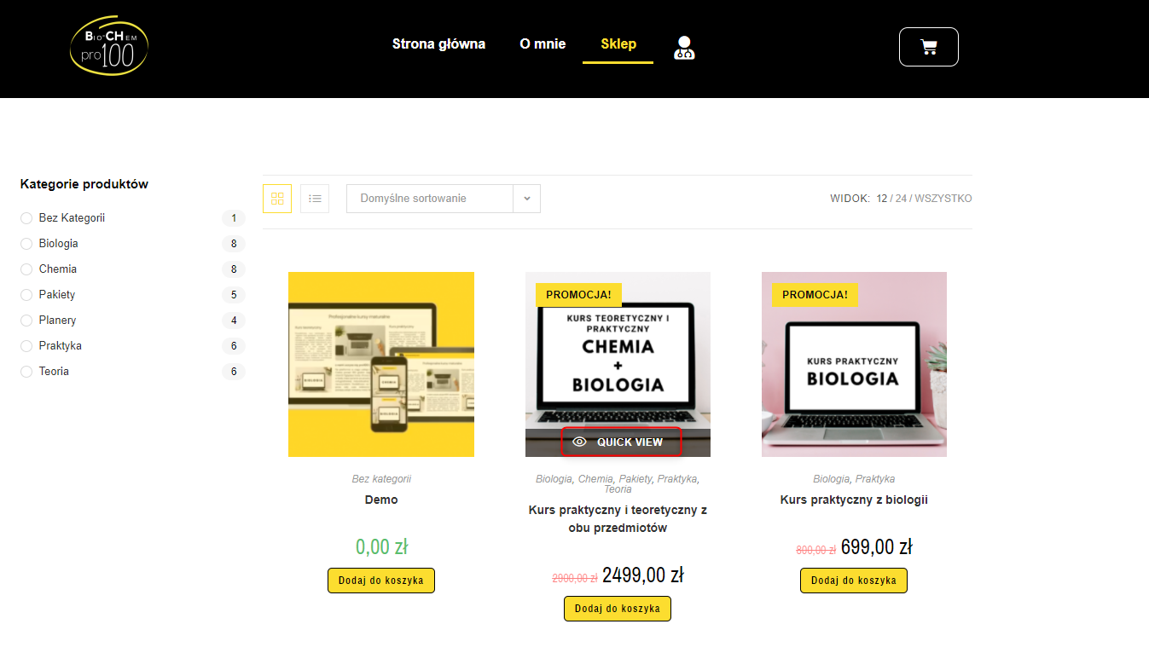

„Quick view” is in other language than whole page.

### Expected result:

Every text is translated into polish.

## Bug #2

Windows 10 - Login – Foreign language text

**Environment**: Windows 10, Google Chrome 95.0.4638.69 (64-bit)

**Issue** **type**: Visual, Functional

**Frequency:** Every time

### Steps to reproduce:

1. Go to <https://biochempro100.pl/>

2. Go to login page

3. Try to login with incorrect data

### Actual result:

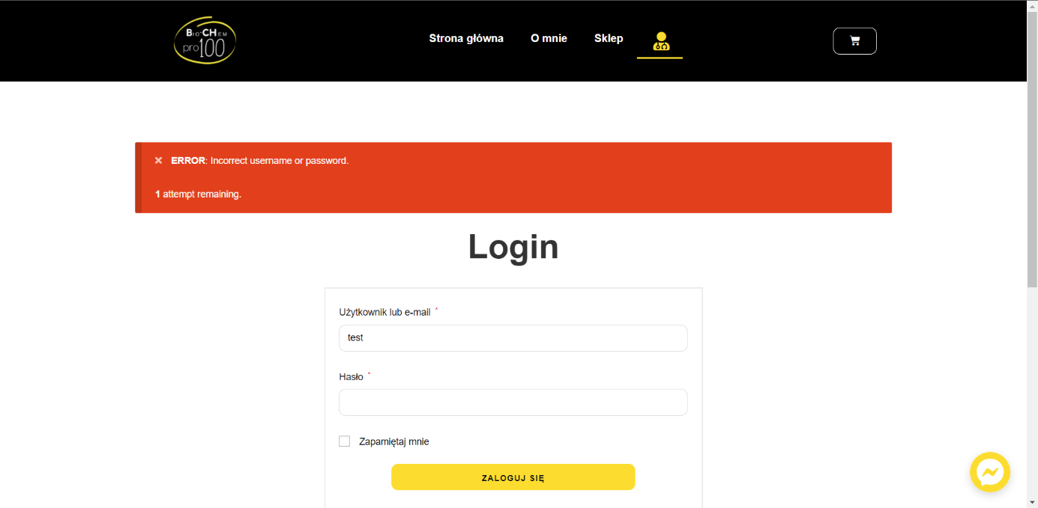

Message with ERROR is diplayed in English.

### Expected result:

Message should be displayed in Polish.

## Bug #3

Windows 10 - Shop – Foreign language text

**Environment**: Windows 10, Google Chrome 95.0.4638.69 (64-bit)

**Issue** **type**: Visual, Functional

**Frequency:** Every time

### Steps to reproduce:

1. Go to <https://biochempro100.pl/>

2. Go to shop section

3. Chose random course and add it to basket

### Actual result:



Message is diplayed in English.

### Expected result:

Message should be displayed in Polish.

## Bug #4

Windows 10 - Main page – Type

**Environment**: Windows 10, Google Chrome 95.0.4638.69 (64-bit)

**Issue** **type**: Typo

**Frequency:** Every time

### Steps to reproduce:

1. Go to <https://biochempro100.pl/>

2. Scroll down to section with „Biologia” and „Chemia”

3. Click on „Chemia praktyka”

### Actual result:

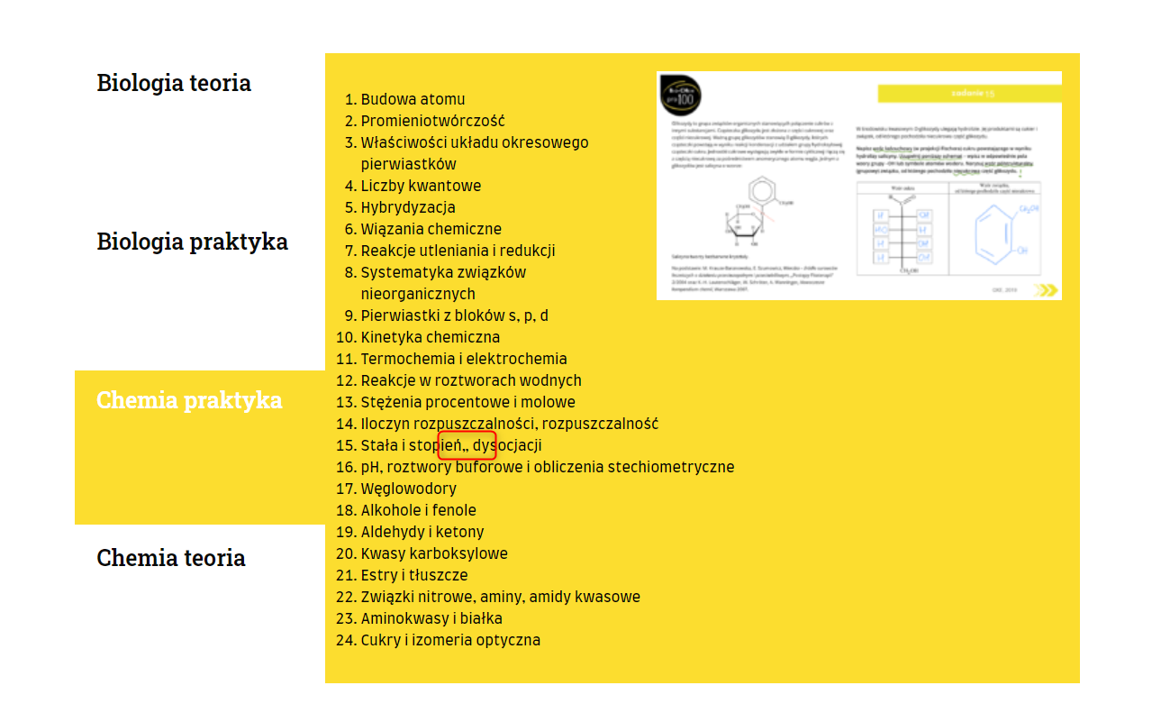

There is a typo in 15. after „stopień”

### Expected result:

„15. Stała i stopień dysocjacji”

## Bug #5

Windows 10 - Main page – Typos

**Environment**: Windows 10, Google Chrome 95.0.4638.69 (64-bit)

**Issue** **type**: Typo

**Frequency:** Every time

### Steps to reproduce:

1. Go to <https://biochempro100.pl/>

2. Scroll a little to „Kurs praktyczny”/”Kurs teoretyczny” section

### Actual result:

Multiple typos in text. In first two capital letters are missing. 3rd there is a space after sentence. Last one „z” should be in the next line.

### Expected result:

1. „(…) maturalnych. Kurs (…)”
2. „(…) żywo. Na (…)”
3. „(…) rozwiązań. Kurs (…)”
4. „z” to next line.

## Bug #6

Windows 10 - Product page – Text under buttons

**Environment**: Windows 10, Google Chrome 95.0.4638.69 (64-bit)

**Issue** **type**: Visual, Functional

**Frequency:** Every time

### Steps to reproduce:

1. Go to <https://biochempro100.pl/>

2. Go to shop

3. Select random course with longer name

### Actual result:

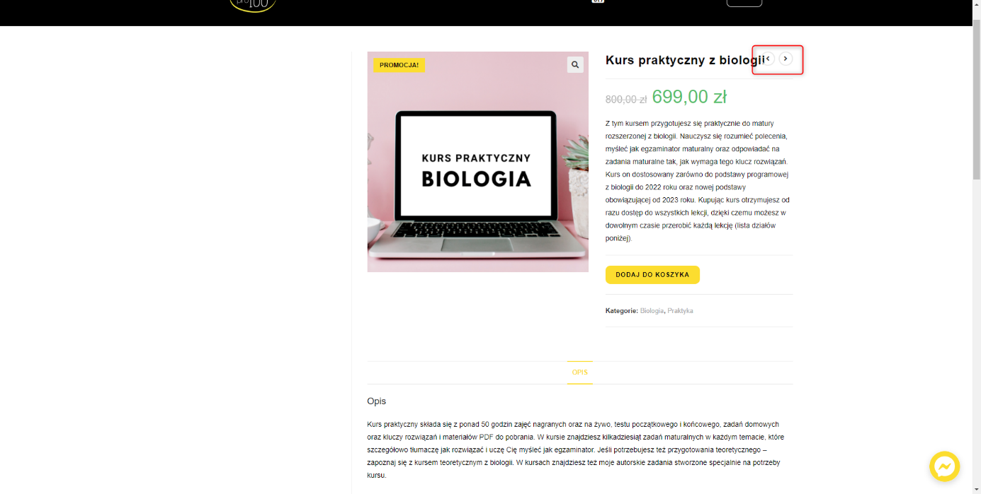

Text is under the buttons.

### Expected result:

Text should be separate with buttons.

## Bug #7

Windows 10 - Shop – Foreign language text

**Environment**: Windows 10, Google Chrome 95.0.4638.69 (64-bit)

**Issue** **type**: Visual, Functional

**Frequency:** Every time

### Steps to reproduce:

1. Go to <https://biochempro100.pl/>

2. Go to shop

### Actual result:



Icons are uneven when you hover on it on the top bar.

Pictures from this same template are slightly uneven.

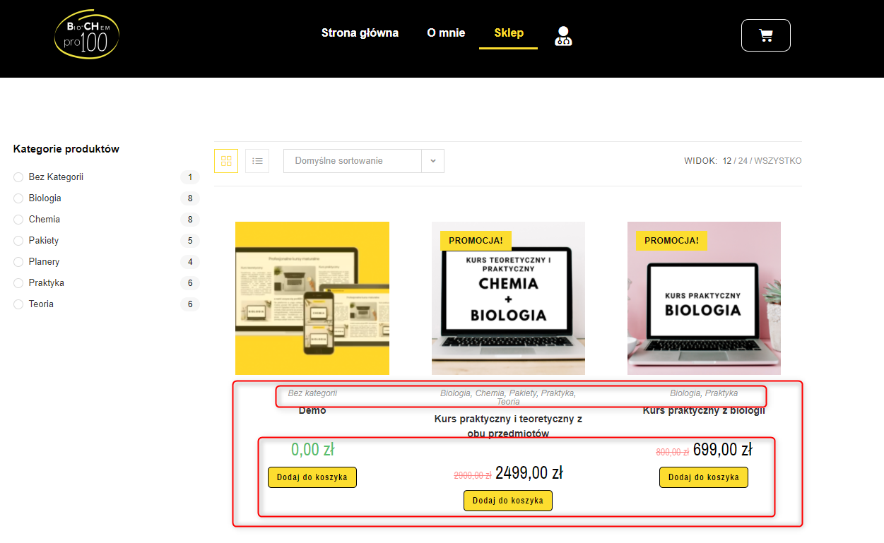

Because of the long text in categories everything else fell apart.

### Expected result:

Every section should be even. Space for categories and courses names should be increased to contain the text.

## Bug #8

Windows 10 - Main page – Typo

**Environment**: Windows 10, Google Chrome 95.0.4638.69 (64-bit)

**Issue** **type**: Typo

**Frequency:** Every time

### Steps to reproduce:

1. Go to <https://biochempro100.pl/>

### Actual result:

Typo in „Polityka prywatnośći”.

### Expected result:

„Polityka prywatności”

## Bug #10

Windows 10 - Checkout page – Wrong name of process

**Environment**: Windows 10, Google Chrome 95.0.4638.69 (64-bit)

**Issue** **type**: Typo

**Frequency:** Every time

### Steps to reproduce:

1. Go to <https://biochempro100.pl/>

2. Add something to basket

3. Go to checkout

### Actual result:

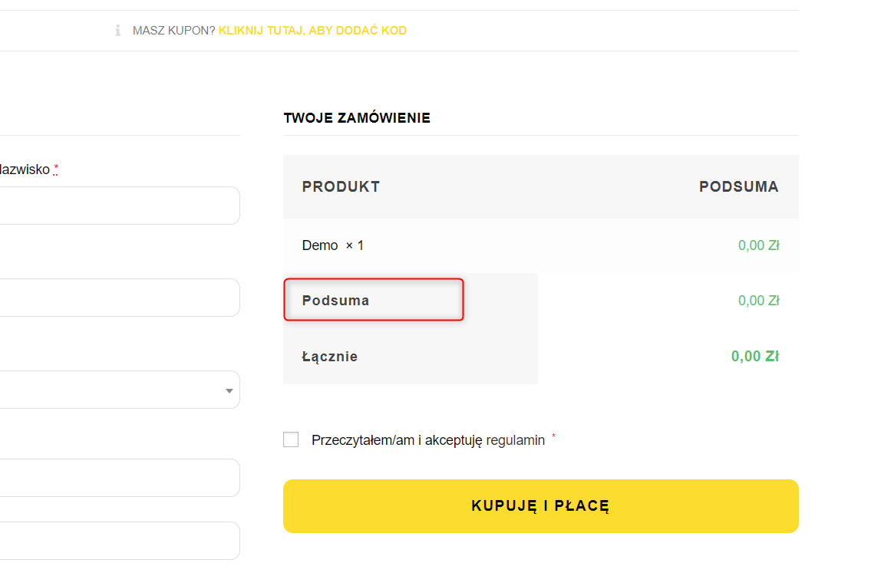

### Expected result:

It should be „Podsumowanie” or „Suma” in both places (near „PRODUKT” nad under name of course).

## Bug #11

Windows 10 - Main page – „Polityka prywatności” and Messenger

**Environment**: Windows 10, Google Chrome 95.0.4638.69 (64-bit)

**Issue** **type**: Visual

**Frequency:** Every time

### Steps to reproduce:

1. Go to <https://biochempro100.pl/>

### Actual result:

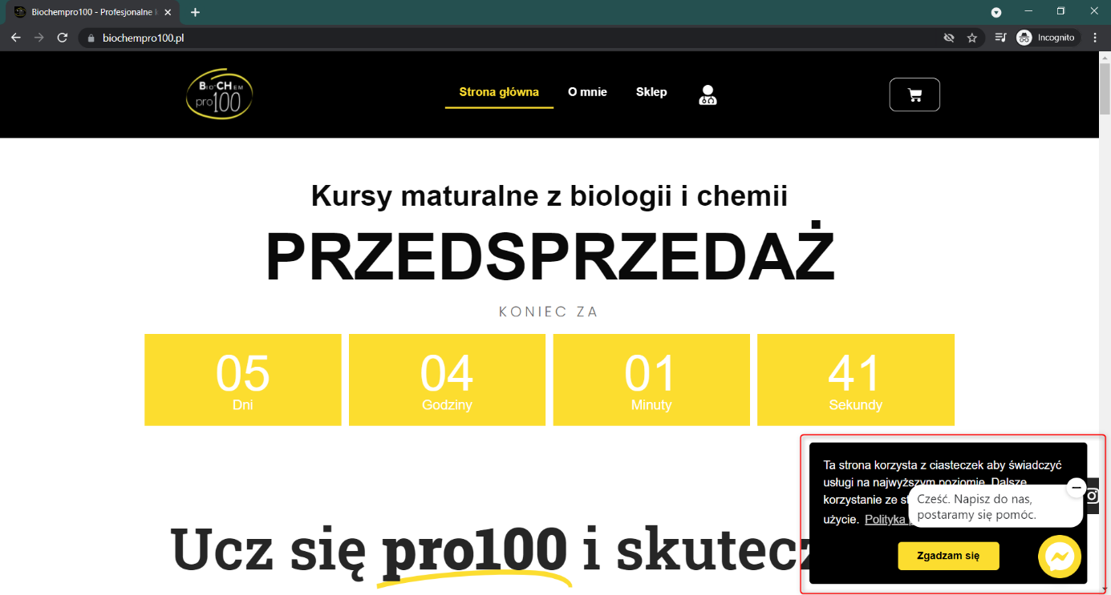

„Polityka prywatności” and Messenger widgetes overlap.

### Expected result:

To be transparent one of widgetes should be in separate section of the page, than the other one.

## Bug #12

Windows 10 – Shop – Page not found

**Environment**: Windows 10, Google Chrome 95.0.4638.69 (64-bit)

**Issue** **type**: Functional

**Frequency:** Every time

### Steps to reproduce:

1. Go to <https://biochempro100.pl/>

2. Scroll to the end

3. Go to „Sklep”

### Actual result:

Page not found.

### Expected result:

It should take us to biochempro100.pl/sklep and then it display fine.